**Experiment Part A**

Follow the next steps and tasks, in some of them you will be requested to take screenshots, record your time or upload files.

**Task 1 (Deriving a different product).**

**Current time (put the time when you are ready to start this task)** __HH:MM___

* Go to Stores1 root folder. Delete the next folders:
  + Src/controllers
  + Src/models
  + WebContent/css
  + WebContent/views
* Go to VariaMos click over “Binding Model”. Select all features to be integrated and Execute a new derivation.
* Click “customize derivation” and put “Welcome to this App” instead of “Welcome to Stores”
* Copy the derived folders, inside you project root folder.
* Refresh the project (F5).
* Run the new project (right click over the project -> Run -> Run on Server -> Select Apache -> Finish
* Go to your browser and open the /Products link, something like this (port could be different): <http://localhost:8080/Stores1/Home>

Take a screenshot and put it here:

* Go to your browser and open the /Products link, something like this (port could be different): <http://localhost:8080/Stores1/Products>

Take a screenshot and put it here:

**Final time (record your current time after finishing this task):** __HH:MM___

**Task 2 (Understanding fragments).**

**Current time (put the time when you are ready to start this task)** __HH:MM___

* Open your WebContent/views/header.jsp and inspect the code
* What is the name of the component(s) which make alterations over the header.jsp file?

_______________________________________________________________

_______________________________________________________________

* What is the name of the fragmentation point involved in those alterations?

_______________________________________________________________

* What do those alterations mean, what did they added?

_______________________________________________________________

_______________________________________________________________

**Final time (record your current time after finishing this task):** __HH:MM___

**Task 3 (Modifying a domain component).**

**Current time (put the time when you are ready to start this task)** __HH:MM___

* Suppose you are requested to make this change directly over your pool of components.
* Replace the text “Heading #1” with “Shipping info”

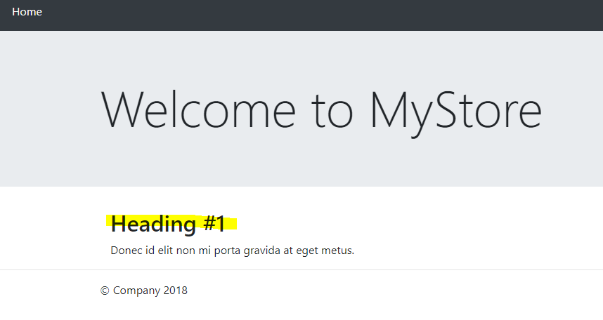

* Try to find inside your component pool what file is responsible for showing that message and make the requested modification.

Take a screenshot of your new component file code and put it here:

**Final time (record your current time after finishing this task):** __HH:MM___

**Task 4 (Creating a new fragmentation point and fragment).**

**Current time (put the time when you are ready to start this task)** __HH:MM___

* Suppose that you are requested to add a new feature and a new component.
* New feature will be called Discount (optional).
* New component will be called Discount.
* If this feature is selected to integrated will make the next change over the derived product:

This is the derived Product.Java getPrice method (by default)



This should be the derived Product.Java getPrice method (if Discount feature was selected to integrate)



* Try to create a fragment (inside the Discount component folder) and a fragmentation point (Over the Product.java file) which satisfy the previous requirement.

Take a screenshot of your new fragment file code and put it here:

Take a screenshot of the Product.java file and put it here:

Take a screenshot of your new feature model (VariaMos) and put it here:

Take a screenshot of your new domain components model (VariaMos) and put it here:

Take a screenshot of your new binding model (VariaMos) and put it here:

**Final time (record your current time after finishing this task):** __HH:MM___

**Task 5 (Deriving a new product).**

**Current time (put the time when you are ready to start this task)** __HH:MM___

* Go to Stores1 root folder. Delete the next folders:
  + Src/controllers
  + Src/models
  + WebContent/css
  + WebContent/views
* Go to VariaMos click over “Binding Model”. Select all features to be integrated (including Discount) and Execute a new derivation.
* Copy the derived folders, inside you project root folder.
* Refresh the project (F5).
* Run the new project (right click over the project -> Run -> Run on Server -> Select Apache -> Finish
* Go to your browser and open the /Products link, something like this (port could be different): <http://localhost:8080/Stores1/Products>

Take a screenshot and put it here:

**Final time (record your current time after finishing this task):** __HH:MM___

**FINALLY**

**Compress your component pool in a .rar file and upload it to your google drive subject folder.**